1.BUILD A MANUAL CI-CD PIPELINE FOR A JAVA APPLICATION AND ALSO A WRITE A SIMPLE TEST.SH FOR TESTING AFTER THAT CONVERT THE SAME IN AUTOMATED CI-CD PIPELINE USING JENKINS BUT YOU HAVE TO ALSO USE MAVEN FOR JAVE APPLICATION.

* 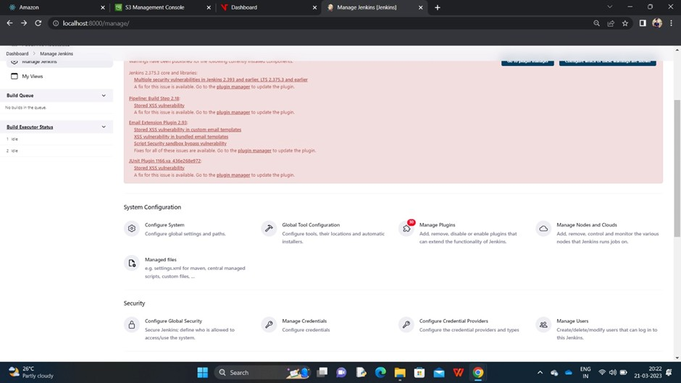manage Jenkins
* Installing plugins ->maven integration and maven pipeline integration

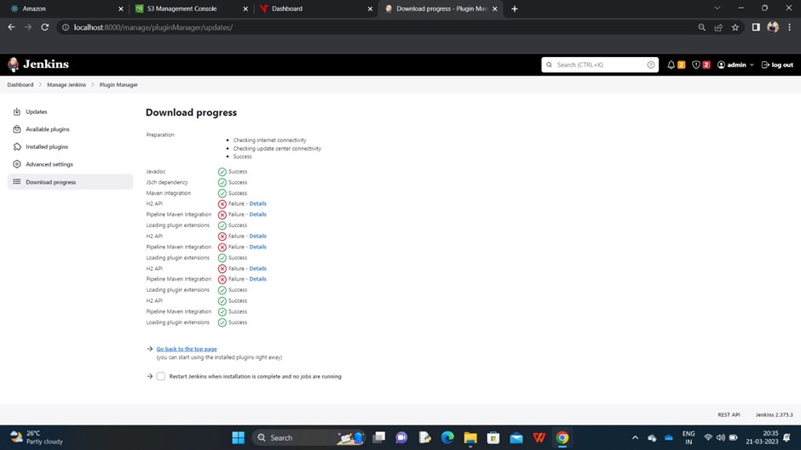

* Conﬁgure settings

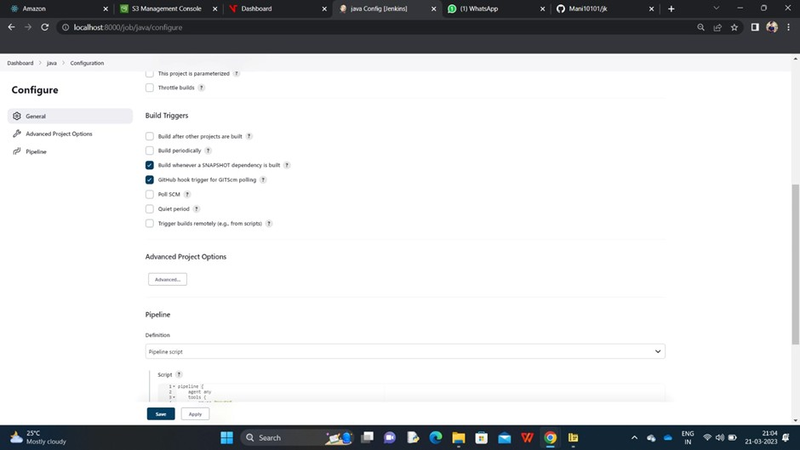

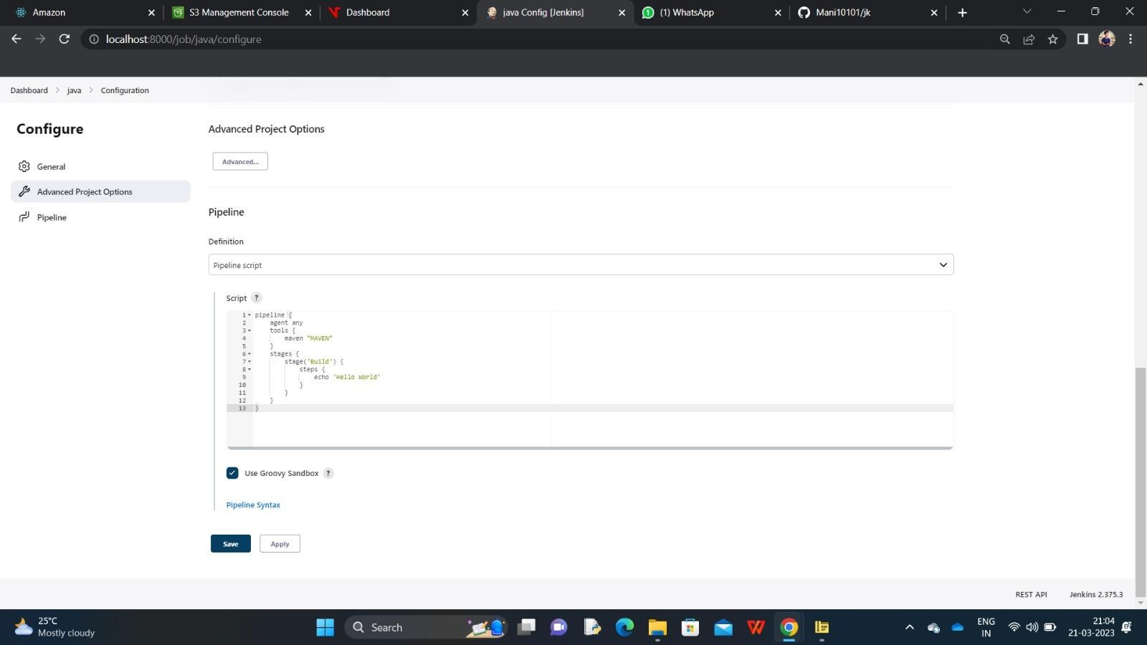

* Global tool conﬁguration settings

